**HORMISDALLEN SCHOOL - KYEBANDO**

**PRE-PLE SET 2 EXAMINATION, 2023**

**PRIMARY SEVEN SCIENCE**

Duration: 2 Hours 15 Minutes

**NAME: ______________________________________________ STREAM: ___________**

EMIS NO.

INDEX NO.

**SECTION A (40 MARKS)**

1. Name any one raw material needed by plants to make their own food?

__________________________________________________________________________________

1. How does severe diarrhoea affect the body?

__________________________________________________________________________________

1. State any one reason why a fresh cut on the body should be covered.

__________________________________________________________________________________

1. Give any one way fungi is useful in the control of diseases.

_________________________________________________________________________________

1. What type of changes take place during the rain cycle?

_________________________________________________________________________________

1. State any one way of demagnetizing temporally magnets.

__________________________________________________________________________________

**Study the diagrams about light below and answer questions 7 and 8.**

**A B**



1. Which of the two diagrams **A** and **B** represents a ray of light?

__________________________________________________________________________________

1. Give a reason to support your answer given for No.7 above

__________________________________________________________________________________

1. State any one benefit of family members having different bedrooms.

__________________________________________________________________________________

1. Give one way of preventing boiled water from getting contaminated again.

___________________________________________________________________________________

1. What is the role of oxygen during respiration?

___________________________________________________________________________________

___________________________________________________________________________________

1. How are fish adapted to overcoming friction as they move in water?

__________________________________________________________________________________

1. State one way of protecting our houses against wind damage.

________________________________________________________________________________

1. How do cattle farmers stimulate milk let-down before milking?

___________________________________________________________________________________

1. How do packers of drinks prepare for the effect expansion? ___________________________________________________________________

___________________________________________________________________________________

1. State any one reason why a tape worm does not have a digestive system.

____________________________________________________________________________________

1. Why do fruits develop an attractive colour as they ripen?

___________________________________________________________________________________

**The diagram below shows a human heart. Study it and answer questions 18 and 19.**

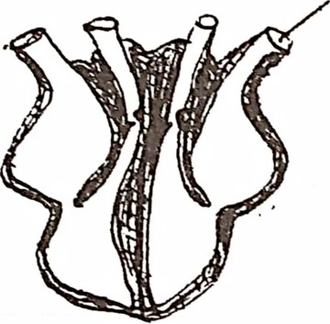 R

1. Name blood vessel **R**. __________________________________________________________________
2. Use a line segmented and letter **M** to show the pulmonary artery.

___________________________________________________________________________________

1. State **any** one way of reducing the amount of wood fuel used at home.

___________________________________________________________________________________

1. How does the AIDS virus lower the immunity of a person living with it.

___________________________________________________________________________________

1. Which disease in humans is spread through tsetsefly bites?

__________________________________________________________________________________

1. State any one reason why sandy soil does not hold water for a long time.

______________________________________________

1. Give any one poultry management practice that helps to control egg eating.

_________________________________________________________________________________

1. How does the feeding of a lion save the vegetation of an area?

__________________________________________________________________________________

1. What type of a simple machine is used for cutting?

__________________________________________________________________________________

1. A part from proper feeding, give one other way of boosting the immunity of a baby.

___________________________________________________________________________________

1. How do plants benefit from moving air during flowering time?

___________________________________________________________________________________

1. Give one way of reducing the moisture content in the harvested crops before storage.

___________________________________________________________________________________

1. Which deficiency disease affects the muscular skeletal system.

__________________________________________________________________________________

1. In which state of matter are clouds in the atmosphere?

__________________________________________________________________________________

1. How are monotremes different from other mammals in terms of reproduction?

___________________________________________________________________________________

**Study the diagram below about heat transfer and answer questions 33 and 34.**

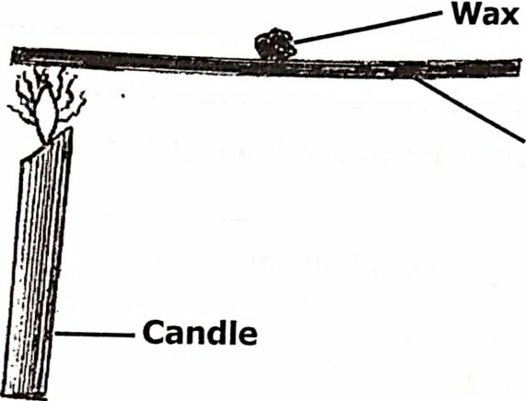

1. What method of heat transfer is shown by the diagram?

___________________________________________________________________________________

1. How can one know that heat has reached the point where wax is placed?

____________________________________________________________________________________

__________________________________________________________________________________

1. State one way people in the community can avoid sexual diviations.

____________________________________________________________________________________

1. Name the document that helps in the monitoring of child growth.

____________________________________________________________________________________

1. Give one way of controlling the spread of malaria without using chemicals.

________________________________________________________________________________________

1. State any one factor that determines the size of a shadow of an object.

___________________________________________________________________________________

1. How does dumping of plastic wastes along water channels lead to floods?

___________________________________________________________________________________

1. Give any one personal hygiene practice that help adolescents to manage body changes.

___________________________________________________________________________________

**SECTION B**

1. Apart from bad touches, give any two other behaviour that put the youth at risk of engaging in early sex.
2. ___________________________________________________________________________________

(ii) ___________________________________________________________________________________

b) How do bad touches increase the risk of engaging in early sex?

_________________________________________________________________________________

c) Give one danger of engaging in sex at an early age.

____________________________________________________________________________________________

1. a) What type of change is rusting?

______________________________________________________________________________

b) Give any one condition necessary for rusting.

____________________________________________________________________________________

c) State any two ways of protecting metals against the conditions for rusting. (i)___________________________________________________________________________________

(ii) ____________________________________________________________________________________

1. a) State any one reason why a nursery bed should have a shelter.

__________________________________________________________________________________

b) Apart from shelter, give any two things needed by seedlings in a nursery bed.

i) _______________________________________________________________________________

ii) _______________________________________________________________________________

c) Why should a shelter be removed when the seedlings are about to be transplanted?

___________________________________________________________________________________

1. (a) What term is used to mean the practice of controlling the number of children married people should have?

______________________________________________________________________________

b) Give any two natural methods that can be used to control frequent pregnancies in marriage

(i) _____________________________________________________________________________

(ii) ____________________________________________________________________________

c) State any one advantage of using natural methods of controlling frequent pregnancies. __________________________________________________________________

1. **The diagram below shows a human joint. Study it and answer the questions that follow.**

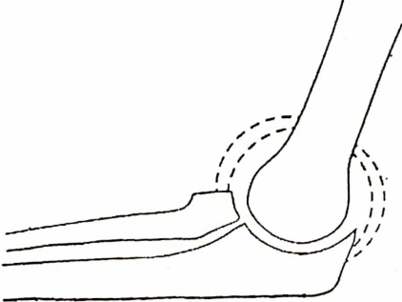

(a) Name the type of movable joints above.

________________________________________________________________________________________

(b) Mention any one place in the human body where the above joint is located.

____________________________________________________________________________

1. Give one item at home that behaves like the above joint.

_________________________________________________________________________________________

(d) State one way of maintaining the above type of joints in a good working condition.

_________________________________________________________________________

1. a) What does the term density mean in terms of matter?

_______________________________________________________________________________________

1. Name the state of matter with the lowest density.

_____________________________________________________________________________

1. How does heat gain affect the density of matter?

________________________________________________________________________

1. State the behaviour of less dense objects when put in water.

____________________________________________________________________________

1. **Match each of the animals in list A with its way of defence in list B.**

**A B**

Snake by camouflaging

Chameleon by biting

Millipede by hiding in its shell

Snail by curling

1. Snake ____________________________________________________________
2. Chameleon _____________________________________________________________
3. Millipede _____________________________________________________________
4. Snail _______________________________________________________________
5. a) Apart from humus, name any two other components of soil?
6. ______________________________________________________________________________
7. _____________________________________________________________________________

b) Give one advantage of humus to plants.

____________________________________________________________________________________

c) State any one way of increasing the amount of humus in the garden.

_____________________________________________________________________________

1. **The diagram below shows parts of the human ear. Study it and answer the questions that follow.**

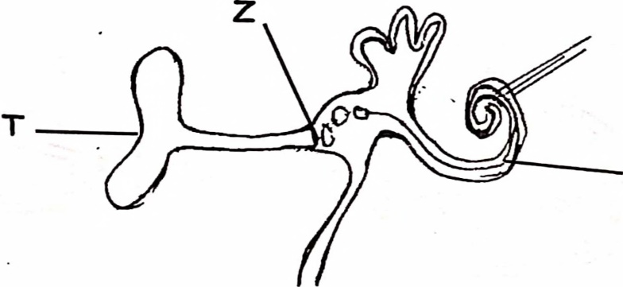

**Y**

1. Name part **T**.

________________________________________________________________________

1. State the function of part **Z** and **Y**.
2. **Z** _________________________________________________________________________
3. **Y** _________________________________________________________________________

c) Use letter **X** and a line segment to show the part that regulates air pressure inside the ear.

_____________________________________________________________________________________

1. (a) Name any one type of bees found in a hive.

_____________________________________________________________________________

(b) State any one difference between nectar and honey.

_______________________________________________________________________________

1. Give one advantage of having a beehive in a crop garden.

_______________________________________________________________________________

(d) Write down one way of caring for bees.

__________________________________________________________________________________

1. **The diagram below shows two leaves of different venation. Study them and answer the questions that follow.**

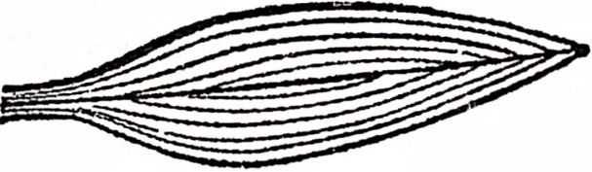 **A B**

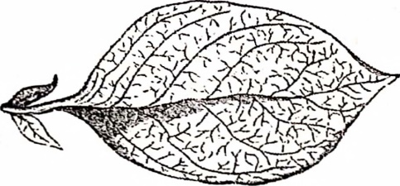

1. Name the type of venation A and B
2. A ______________________________________________________________________________
3. B ______________________________________________________________________________

(b) Which of the two diagrams represents a leaf of a monocot?

______________________________________________________________________________

(c) Give any one similarity in structure between the two leaves.  
 ________________________________________________________________________________________

1. Complete the table about the items used to promote personal hygiene and their uses.

|  |  |
| --- | --- |
| **Item** | **Use** |
|  | For grooming finger nails |
| Toothbrush |  |
|  | For combing hair |
| Sponge |  |

1. (a) Name any two protecting materials used when handling rubbish.
2. ____________________________________________________________________________________
3. __________________________________________________________________________________

(b) Apart from using it in the garden, give one other way rubbish can be useful to humans.

________________________________________________________________________________________

(c) State any one reason why rubbish should be sorted before putting it in the garden.

________________________________________________________________________________________

1. The diagram below shows a foot of a bird. Study it and answer the questions that follow.

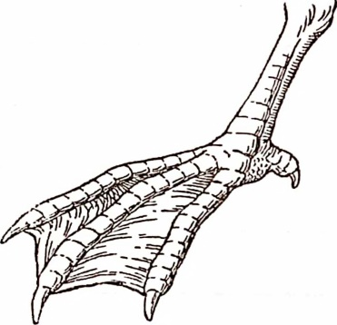

a) Name the type of birds with such a foot. _______________________________________________________________

b) In which environment do birds with such a foot commonly live? ______________________________________________________________________

c) How do birds benefit from having such a foot?

_______________________________________________________________________________

d) Apart from the foot, name one other body feature used to identify different types of birds. ________________________________________________________________________________

1. You are provided with the items below. study them and answer the questions that follow.

* **Charcoal**
* **Water**
* **Turbine**

1. In three sentences, explain how you can produce electricity using the above items.
2. __________________________________________________________________
3. ______________________________________________________________________
4. ______________________________________________________________________
5. Name one physical process involved in production of electricity using the above items.

___________________________________________________________________

1. Apart from the foot, name one other body feature used to identify different types of birds.

__________________________________________________________________________